(Approx. 421 words)

Open Source Lab
KGeography
By Cal Esneault, former President of CCCC and leader of many Open Source Workshops & SIGs, Cajun Clickers Computer Club, LA
March 2014 issue, Cajun Clickers Computer News
www.clickers.org
ccnewsletter (at) cox.net

KDE (K Desktop Environment) is a very popular set of Linux software that is available as the default desktop system for many popular distributions. Since initial release in 1996, it has gone through four major version families (KDE 1.x, 2.x, 3.x, and 4.x). With the release of the developmental toolkit Qt 4, much of the KDE software will soon also be available for Microsoft Windows and Mac OS X.

What you may fail to realize is that there are many useful applications available through the KDE Community web site. For example, from the site kde.org/applications/education, the list shown below is a limited sample of available software. One that I recently tried for my Ubuntu system was KGeography (note that many KDE applications have the letter "K" prominently displayed in the title).
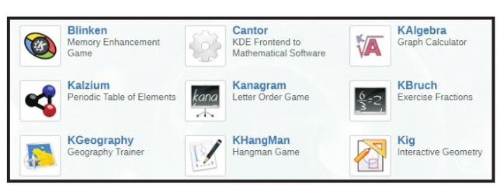

In KGeography, you first choose the country map that you want to investigate. Below I have selected France. Within each map the next geographic subdivision is displayed on the map (possible options include regions, territories, counties, etc.).

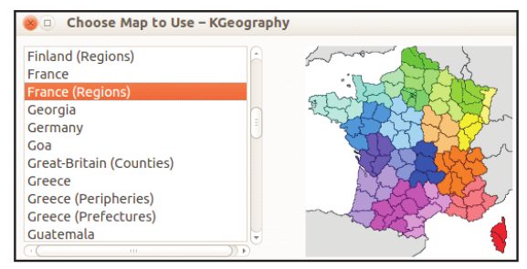

After selecting the map of the desired country, a larger map is displayed along with a side panel consisting of several categories for you to test and build your geographical knowledge. For example, the next map shows the country of Canada as a selection with its provinces outlined with different color schemes. By clicking on each province, you will get a display of the province's name, capital, and flag.
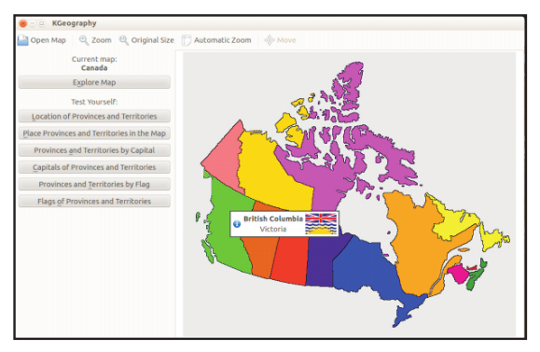

After you become familiar with the information, there is a "Test Yourself" section where you can be queried to identify the location, capital, or flag of a series of provinces. At the end of the quiz, you will get the score and results of each question. Below is a sample result of a series of 5 questions.

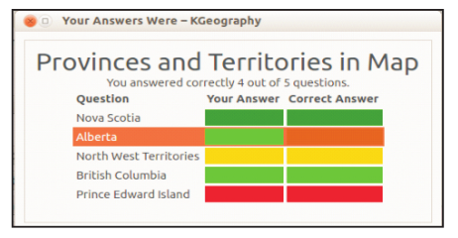

KGeography provides an entertaining way to familiarize you or your children with the details of many countries. Well-known locations are the easiest to start, but you will be challenged as you work you way through less familiar sites. My experience was that flag identification was the most difficult.

This is only one example of a KDE education application. There are many others types of programs available in such categories as office, multimedia, graphics, business, games, screensavers, etc. Currently these apps are available through the repository of most modern Linux distributions. Enjoy!

